Pokhara University

Level: Bachelor | Semester – Spring | Year : 2007
Programme: BE |  | Full Marks: 100
Course: Logic Circuits |  | Time : 3hrs.

Candidates are required to give their answers in their own words as far as practicable.
The figures in the margin indicate full marks.

Attempt all the questions.

 | - Today digital system is preferred over analog system. Why? Give reasons.  - Convert the following numbers from the given base to the other bases indicated:  - Octal 777 to decimal, binary and hexadecimal.  - Hexadecimal 3A9 to decimal and binary.  c) What is parity bit? Explain about even and odd parity method of error detection. | 5  3+2  5
 | - Implement the given Boolean function F = (AB +CD) + BC' using NAND gates only.  - With the help of circuit diagram explain the function of Status Register.  - Explain different types of output hazard races in combinational circuits. | 5  5  5
 | - Design a code converter circuit that can convert 3 bit decimal code to excess- 3 code.  - Design a combinational circuit whose input is a four-bit number and whose output is the 2's complement of the input numbers. | 8  7
 | - What is magnitude comparator? Design a two bit magnitude comparator whose outputs are A<B, A>B and A = B.  - List out the differences between PLA and ROM. Implement the given function using PLA.  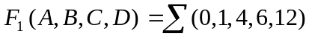  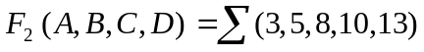 | 8  7
 | - Simplify the Boolean function 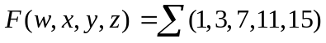that has don't care condition 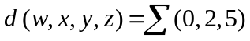and draw the circuit using NAND – NAND gates.  - For the given logic equation:  F = AB + B' CB + A'B  i) make a truth table  ii) simplify using K-map  iii) realize using NOR gates only | 7  8
 | - What do you mean by flip flop? What is the drawback of R-S flip flop? Draw the logic diagram and characteristic table of flip-flop used to solve the problem of R-S flip-flop.  - What is a shift register? Explain how the addition of two binary numbers can be performed using shift registers.  - Explain the operation of master slave flip-flop. | 5  5  5
 | Write short notes on (Any Two):  - 4 bit binary ripple counter  - Nibble adder  - Sequential circuit and combinational circuit  - Synchronous and asynchronous logic | 2×5

